**Laptop** **Sales** **(Case** **Study-2)**

NAME – **VIPUL** **PANDEY**

EMAIL ID – [**VIPUL97PANDEY@GMAIL.C**](mailto:VIPUL97PANDEY@GMAIL.COM)**OM**

**Relationship** **between** **distance** **(b/w** **Store** **and** **customer** **location)** **and** **sales** **of** **stores.**

• How far do customers travel to buy their laptops?

• Does store proximity to customers help to increase the sales of the stores?

|  |  |  |  |  |  |
| --- | --- | --- | --- | --- | --- |
| **DISTANCE** | **PERCENTAGE** | **TOTAL** **VOLUME** **(** **in** **Rs.)** | **TOTAL** **REVENUE** **(** **in** **Rs.)** | **TOTAL** **VOLUME** **(%)** | **TOTAL** **REVENUE** **(%)** |
| <=8 km | 96.64897 | 293948 | 1.47E+08 | 98.83495 | 98.8448 |
| 6-18 Km | 2.782894 | 3117 | 1552960 | 1.048038 | 1.041207 |
| >18 km | 0.568132 | 348 | 170160 | 0.117009 | 0.114086 |

**Approximately** **97%** **of** **the** **consumers** **purchase** **laptops** **from** **the** **stores** **that** **are** **within** **8km** **distance** **from** **their** **houses.**

**Total** **volume** **(** **98%** **approx.** **)** **of** **the** **store** **volume** **and** **revenue** **comes** **from** **the** **consumers** **that** **live** **within** **8** **km** **distance** **of** **the** **store.**

**Hence,** **it** **can** **be** **concluded** **that** **store** **proximity** **helps** **to** **increase** **the** **sales** **of** **the** **laptop.**

**Does** **the** **laptop** **price** **change** **with** **time?** 600

500 Jan Feb

March 400 April

May

300 June July

August 200 September

Oct

100 Nov

Dec

0

1 2 3 4 5 6 7 8 9 10 11 12 13 14 15 16 17 18 19 20

**For** **each** **configuration,** **the** **laptop** **price** **decreases** **with** **each** **subsequent** **month** **(** **from** **Jan** **to** **Dec)** **as** **it** **can** **be** **interpreted** **from** **the** **graph.**

**This** **decrease** **is** **approximately** **equal** **to** **Rs.** **5** **each** **month** **which** **results** **in** **the** **average** **decrease** **of** **around** **35%** **from** **January** **to** **December.**

**The** **prices** **also** **decrease** **enormously** **at** **the** **end** **of** **each** **quarter.**

**The** **numbers** **1-20** **on** **the** **x-axis** **represent** **the** **first** **twenty** **configurations**.

**Are** **the** **Laptop** **prices** **consistent** **across** **all** **retail** **outlets?**

370

370

370

370

370

370

370

365

365

365

365

365

365

365

360

360

360

360

360

360

360

370

365

**AVERAGE** **LAPTOP** **PRICES** **ACROSS** **ALL** **STORES** **FOR** **JAN-JUNE** **(FOR** **CONFIGURATION** **1)**

CR7 8LE E2 0RY KT2 5AU NW5 2QH SE1 2BN SE8 3JD SW12 9HD SW18 1NN SW1P 3AU

252

241.5

252

241.5

252

355

355

355

355

355

355

350

350

350

350

350

350

350

350

350

350

345

345

345

345

345

345

345

355

SW1V 4QQ W10 6HQ

1 2 3 4 5 6 W4 3PH

**Average** **laptop** **prices** **across** **all** **stores** **for** **July-Dec** **(for** **configuration** **1)** CR7 8LE E2 0RY

220.5

231

220.5

340

340

340

340

340

340

340

340

340

E7 8NW KT2 5AU N17 6QA N3 1DH NW5 2QH SE1 2BN SE8 3JD SW12 9HD SW18 1NN SW1P 3AU SW1V 4QQ

335

335

335

335

335

335

335

335

335

335

335

330

330

325

325

325

325

325

325

320

320

320

320

320

320

320

315

315

315

315

315

330

315

231

330

330

325

315

315

W10 6HQ 7 8 9 10 11 12 W4 3PH

**The** **prices** **are** **consistent** **over** **all** **the** **stores** **except** **for** **the** **stores** **“CR7** **8LE”** **and** **“SW1P** **3AU”.** **These** **stores** **offer** **discounts** **at** **the** **end** **of** **every** **quarter.** **The** **discount** **is** **equivalent** **to** **30%.** **Some** **other** **stores** **like** **“E7** **8NW”** **and** **“N3** **1DH”** **also** **tend** **to** **offer** **discounts** **at** **the** **end** **of** **each** **year.**

**Which** **stores** **are** **selling** **the** **most?**

**The** **stores** **with** **the** **postcode** **SW1P** **3AU,** **SE12BN,** **SW1V4QQ,** **NW5** **2QH,** **E2** **0RY** **are** **selling** **the** **most.**

**Their** **total** **revenue** **accounts** **for** **19%(approx.),** **15%** **(approx.)** **,** **15%(approx.),** **11%(approx.),** **11%(approx.)** **respectively** **of** **the** **total** **revenue.**

|  |  |  |  |  |
| --- | --- | --- | --- | --- |
| **Store** **Postcode** | **Volume** **per** **store** | **Revenue** **per** **store** **(in** **Rs.)** | **Volume** **per** **store** **(percentage)** | **Revenue** **per** **store** **(percentage)** |
| SW1P 3AU | 61,793 | 27,953,555 | 20.777 | 18.742 |
| SE1 2BN | 44,625 | 23,204,150 | 15.004 | 15.558 |
| SW1V 4QQ | 43,463 | 22,614,570 | 14.614 | 15.162 |
| NW5 2QH | 31,386 | 16,353,850 | 10.553 | 10.965 |
| E2 0RY | 30,690 | 15,964,080 | 10.319 | 10.703 |
| SE8 3JD | 16,588 | 8,636,465 | 5.5774 | 5.7905 |
| SW18 1NN | 14,072 | 7,322,405 | 4.7315 | 4.9094 |
| SW12 9HD | 12,674 | 6,605,970 | 4.2614 | 4.4291 |
| W10 6HQ | 11,728 | 6,099,105 | 3.9433 | 4.0892 |
| CR7 8LE | 7,834 | 3,559,804 | 2.634 | 2.3867 |
| W4 3PH | 6,537 | 2,955,775 | 2.198 | 1.9817 |
| N17 6QA | 4,738 | 2,477,645 | 1.5931 | 1.6612 |
| KT2 5AU | 4,334 | 2,260,055 | 1.4572 | 1.5153 |
| E7 8NW | 3,794 | 1,704,726 | 1.2757 | 1.143 |
| N3 1DH | 3,009 | 1,362,742 | 1.0117 | 0.9137 |
| S1P 3AU | 148 | 75,236 | 0.0498 | 0.0504 |

**Is** **there** **any** **relationship** **between** **sales** **revenue** **and** **sales** **volume?**

**~~l~~****~~/s~~**

**Clearly,** **as** **the** **sales** **per** **store** **decreases,** **the** **revenue** **also** **decreases.**

**The** **top** **five** **stores** **sell** **70%** **of** **the** **total** **volume** **which** **produces** **a** **revenue** **of** **70%.** **The** **rest** **of** **the** **stores** **produce** **30%** **revenue** **and** **sell** **30%** **of** **the** **total** **volume.**

**The** **graph** **represents** **the** **percentages** **of** **sales** **revenue** **and** **sales** **volume** **and** **not** **the** **actual** **number.**

25  **~~Volume v/s Revenue~~**

20

15

10

5

0

SW1P SE1 SW1V NW5 E2 SE8 SW18 SW12 W10 CR7 W4 N17 KT2 E7 N3 S1P 3AU 2BN 4QQ 2QH 0RY 3JD 1NN 9HD 6HQ 8LE 3PH 6QA 5AU 8NW 1DH 3AU

Volume per store (percentage) Revenue per store (percentage)

**Relationship** **between** **different** **configuration** **features** **and** **Laptop** **Prices**



**r** **ric**

Screen Size(in Inches) vs Average Price

1500

1000

500

**RAM** **vs** **Average** **Price**

700 600 500 400 300

200

0

Screen Size (in Inches)

Series1

Average Price

Series2

100

0

1 2 3

RAM Average Price

**Processor** **Speed** **vs** **Average** **Price**

600



**r** **c** **ss** **r** **s** **r** **ric**

500

400

300

200

100

**Battery** **life** **power** **vs** **Average** **Price** 600



**tt** **r** **lif** **r** **s** **r** **ric**

500

400

300

200

100

0

1 2 3

0

1 2 3

Processor Speed Average Price Battery life hours Average Price

**Configuration** **vs** **Average** **Price**

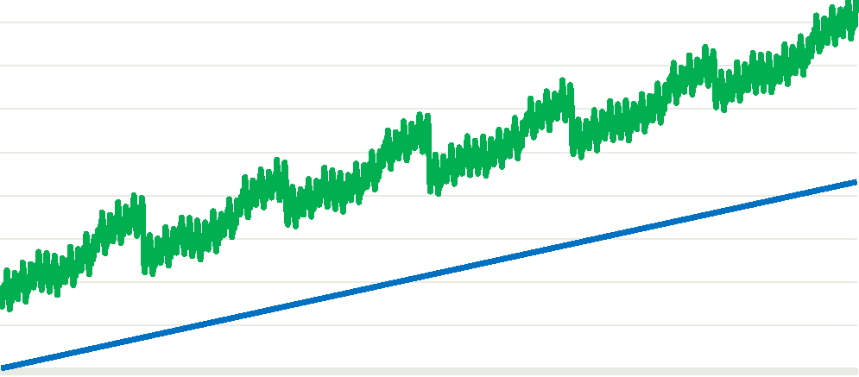

1

32

63

94

125

156

187

218

249

280

311

342

373

404

435

466

497

528

559

590

621

652

683

714

745

776

807

838

**All** **features** **affect** **the** **price** **of** **the** **laptop.** 1800 1600

**Laptop** **prices** **and** **features** **are** **directly** 1400 1200

**related** **to** **each** **other.** **The** **more** **advanced** 1000 800

**the** **feature,** **the** **more** **the** **price.** 600 400

**Amongst** **all** **the** **features,** **the** **configuration** 200 0

**tends** **to** **affect** **the** **prices** **the** **most.**

Configuration Average Price

✓**Reducing** **price** **of** **older** **configuration** **laptop** **might** **result** **in** **increase** **in** **sales.** ✓**Opening** **new** **stores** **in** **different** **locations** **so** **customers** **don’t** **have** **to** **travel** **much.**

✓**Customer** **reviews** **can** **be** **very** **important** **if** **we** **want** **to** **know** **what** **is** **happening** **with** **a** **particular** **model** **or** **a** **particular** **store.** **This** **can** **help** **us** **determine** **if** **there** **are** **other** **factors** **responsible** **for** **low** **sales** **in** **a** **particular** **store.**